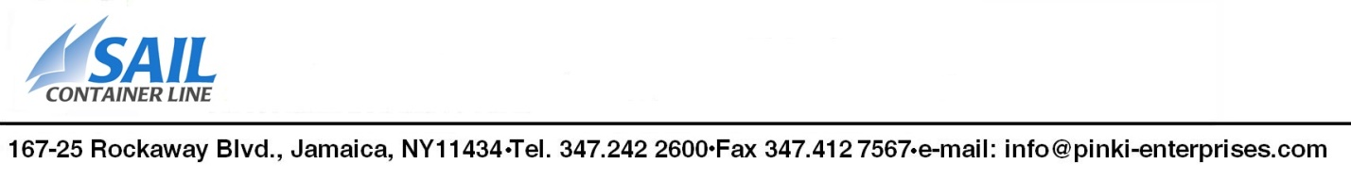
EXPORT POWER OF ATTORNEY
Power of Attorney – Designation of Forwarding Tax ID _______________________ KNOW ALL MEN
BY THESE PRESENTS: That, ____________________________________________ (EXPORTER) organized and doing business under the laws of the State or Country of ________________________ and having an office and place of business at _______________________________________________________________ hereby authorizes Sail Container Line , to act for and on behalf of EXPORTER as a true and lawful agent and attorney for, and in EXPORTER’s name, place, and stead, from this date, in the United States (the “territory”) either in writing, electronically, or by other authorized means, to: act as authorized agent for export control , U.S. Census Bureau reporting, and U.S. Customs and Border Protection (CBP) purposes. Also, to prepare and transmit any Electronic Export Information (EEI) or other documents or records required to be filed by the Census Bureau, CBP, the Bureau of Industry and Security, or any other U.S. Government agency, and perform any other act that may be required by law or regulation in connection with the exportation or transportation of any goods shipped and consigned by or to EXPORTER, and to receive or ship any goods on behalf of the EXPORTER. In the event that EXPORTER is located outside the United States and that any or all of the transactions handled by Sail Container Line under this power of attorney are “routed export transactions” as that term is defined in 15 C.F.R. §30.1 (Foreign Trade Regulations) and 15 C.F.R. Part 772 (Export Administration Regulations), EXPORTER certifies that it will not assume responsibility for determining licensing requirements and obtaining license authority without obtaining Sail Container Line prior written consent. EXPORTER hereby certifies that all statements and information contained in the documentation provided to Sail Container Line and relating to exportation will be true and correct. Furthermore, the EXPORTER understands that civil and criminal penalties may be imposed for making false or fraudulent statements or for the violation of any United States laws of regulations on exportation. This power of attorney is to remain in full force and effect until revocation in writing is duly given by EXPORTER and received by Sail Container Line. The said power of attorney shall in no case have any force or effect in the United States after the expiration 2 years from the dates of its execution. IN WITNESS WHEREOF,
_________________________________________ caused these presents to be sealed and signed: Legal Entity (Exporter)
____________________________________________ Signature
____________________________________________ Signatory Printed Name
____________________________________________ Title (Capacity)
____________________________________________ Date

